**Problem Statement**

You have been asked to:

● Trigger a pipeline using Git when push on Develop branch

● Pipeline should pull git content to a folder

**Solution Approach**

**Step 1: Installed Required Jenkins Plugins**

* **Git Plugin**: Enables Git integration.
* **Pipeline Plugin**: Enables creating pipeline jobs.
* **GitHub Integration Plugin**: Supports webhooks for automatically triggering builds.

**Step 2: Set Up a Git Repository**

* We used the Git Repository for Zendrix Softwares that was set up as part of the git assignment.
* The git repository was set up with a develop branch that would be used to trigger builds.
* Link to repository: <https://github.com/vyombhatt/zendriix-softwares-workflow/tree/develop>
* In the develop branch, we create a ***Jenkinsfile*** that will hold our trigger pipeline as shown below:

1. pipeline {

2.     agent any

3.     stages {

4.         stage('Clone Repository') {

5.             steps {

6.                 // Clone the develop branch into a specific folder

7.                 checkout([

8.                     $class: 'GitSCM',

9.                     branches: [[name: '*/develop']],

10.                     doGenerateSubmoduleConfigurations: false,

11.                     extensions: [[$class: 'RelativeTargetDirectory', relativeTargetDir: 'git-content-folder']],

12.                     userRemoteConfigs: [[url: 'https://github.com/vyombhatt/zendriix-softwares-workflow.git']]

13.                 ])

14.             }

15.         }

16.         stage('Confirm Pull') {

17.             steps {

18.                 echo "Repository content has been pulled to 'git-content-folder'."

19.                 sh 'ls git-content-folder' // List files to verify

20.             }

21.         }

22.     }

23. }

**Step 3: Configure Jenkins Pipeline Job**

1. Set up an EC2 cluster, downloaded Jenkins and logged into Jenkins
2. Created a new **Pipeline in Jenkins**
3. **Configured the Pipeline Job** as follows:
   * **Pipeline Definition**: Used *Pipeline script from SCM*.
   * **SCM**: Chose *Git*.
   * **Repository URL**: *https://github.com/vyombhatt/zendriix-softwares-workflow.git*
   * **Branch Specifier**: */develop

**Step 4: Set Up a Git Webhook**

On GitHub, in order to set up triggers for every push to develop, we set up a Webhook, as shown:

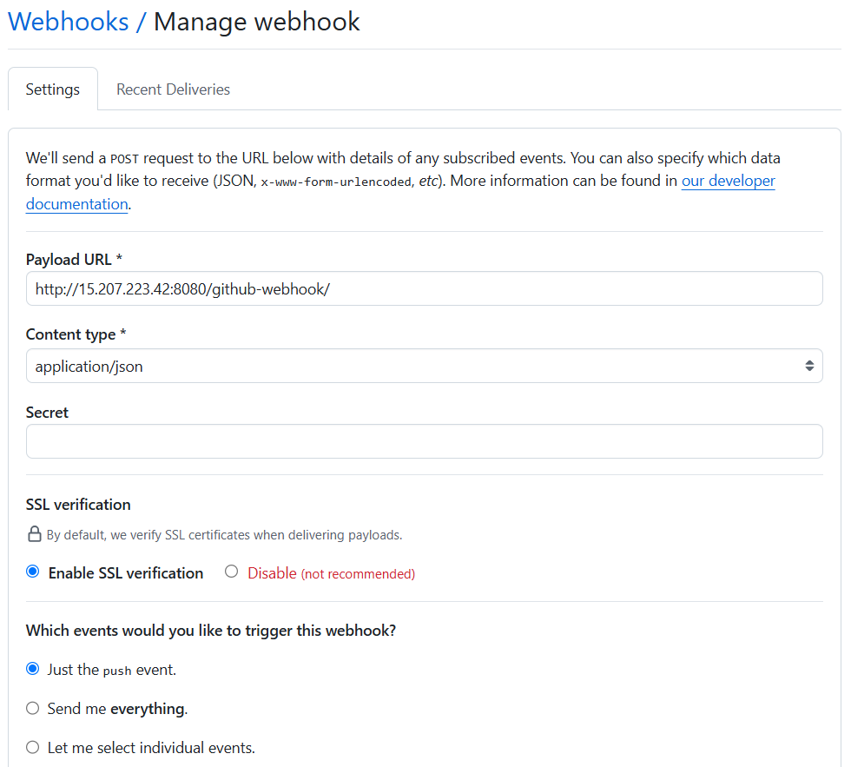

**Step 5: Test the Pipeline**

1. In order to test the pipeline, we made a commit to the develop branch of the git repository and pushed it.
2. The Jenkins job was automatically triggered as shown below:

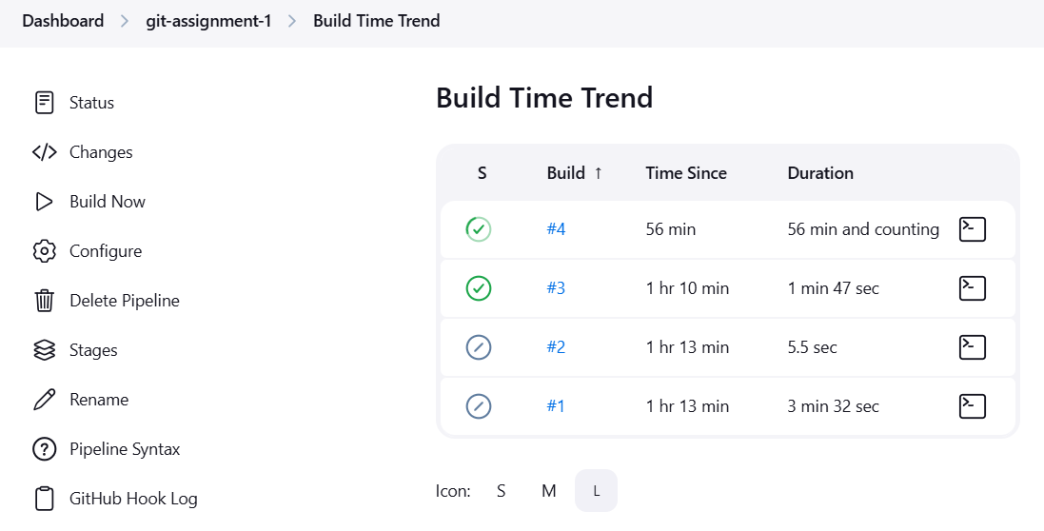

1. The pipeline was able to copy all files from develop folder into the cluster:

